**Department of Computer Science**

Final Project Report, Summer 20-21

|  |  |  |  |
| --- | --- | --- | --- |
| Course Title | Web Technologies | Section | C |

**Group Members:**

|  |  |  |
| --- | --- | --- |
| Student ID | Name | Signature |
| 18-39079-3 | Aisheryo,adnan nasif | Adnan |

**Project Title: Cloud funding**

|  |
| --- |
| Introduction:  Web Technologies – this course is actually skill development-based course. So, we really  want to learn and give our best to this course. On this process we have to complete a project  which will reflect what we were able earn from this course-period. Cloud funding is a financing method that involves funding a project with relatively modest contributions from a large group of individuals, rather than seeking substantial sums from a small number of investors. In here the donar can donate via account. Raiser can raise money edit them. Admin can add admins see and edit everything.    Background Study:  <https://www.businessnewsdaily.com/4134-what-is-crowdfunding.html>-  This project will have  1. User Category:  There are 2-types of Users here. They are:  • Admin  • Donar   * Raiser   2. Feature List:  In this project the “User Type - Admin” has the following features:  • Can add new Donars, Raisers,Admin,  • Can edit them.  • Can view user’s profile.  • Can see user’s location.  • Can view user’s history.  • .Can manage post  • .can search everything  • Payment method  • Generate reports  • approve/reject raiser post.  In this project the “Donar - Agent” has the following features:  Donor:  · Can do registration  · Can see raisers posts  · Can search posts  · Can read posts details  · Can comment on raisers posts  · Manage profile  · Can donate raisers  · Can see own donation history  · Can delete own account  In this project the “Raiser - Agent” has the following features:  · Register to the system  · Can CRUD posts for raising fund  · Can see own posts history  · Can see all posts  · Can search posts  · Can reply own posts comment  · Can check own fund  · Manage profile  · Can make withdraw request  · Can delete own account  Design:    object,  we have used the following:  • Sublime Text3  • Xampp Control panel.  • PHPmyAdmin server. • . • . • Tool N |

System Images against the Specification: Give a screen shot of some GUIs (project) and write a very small description (Maximum 40 words) for each of the GUIs.

This is the login page. But in order to login, one must create a user first. Then one may able to login with password verification..

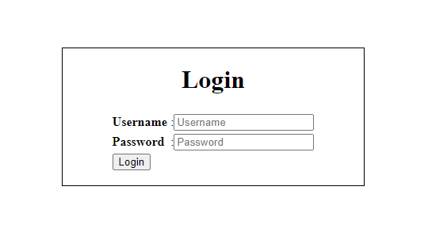

This is the sign in/registration page.

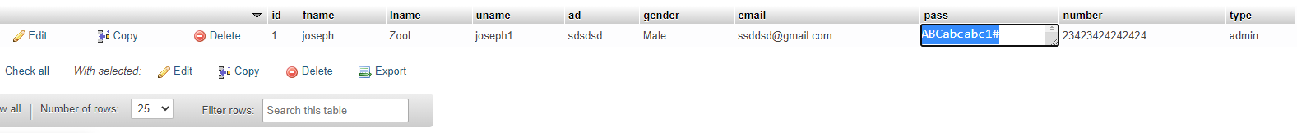

These user are able to login in system use their email and valid password.



Admin Donar,Raiser CRUD list dashboard

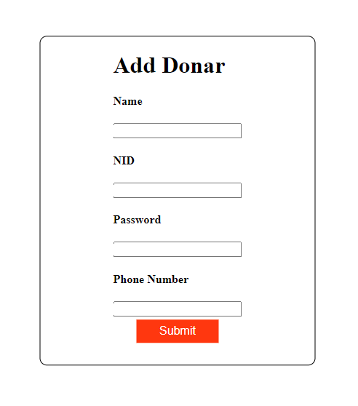

Admin can add Donar,raiser and other admins as well

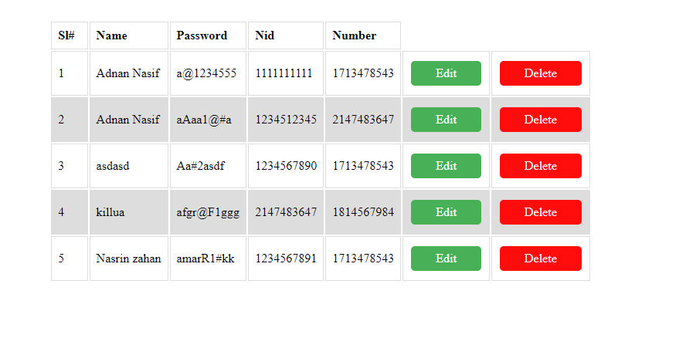

Admin can edit and delete existing users.

**Impact of this Project:**

Cloudfunding is the practice of funding a project or venture by raising small amounts of money from a large number of people, typically via the Internet.[1][2] Cloudfunding is a form of crowdsourcing and alternative finance. In 2015, over US$34 billion were raised worldwide by cloudfunding. Crowdfunding is when businesses, organizations or individuals fund a project or venture with small donations from many people. By receiving the necessary boost to cash flow, these ventures can get off the ground or launch new projects. Most of these campaigns happen via internet platforms, have set time frames for when money can be raised and disclose specific monetary goals.

The files that’s in our project